ASSIGNMENT – 15.4
NAME: A. DINESH
HT.NO: 2403A52080
BATCH NO: AIB04
TASK 1:
PROMPT:
Generate a simple Flask backend in Python with one endpoint that returns a JSON message “Welcome to AI-assisted API”.
CODE:
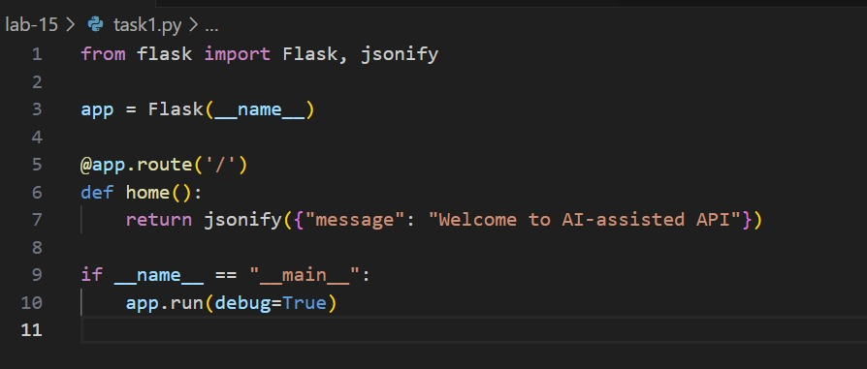
OUTPUT:
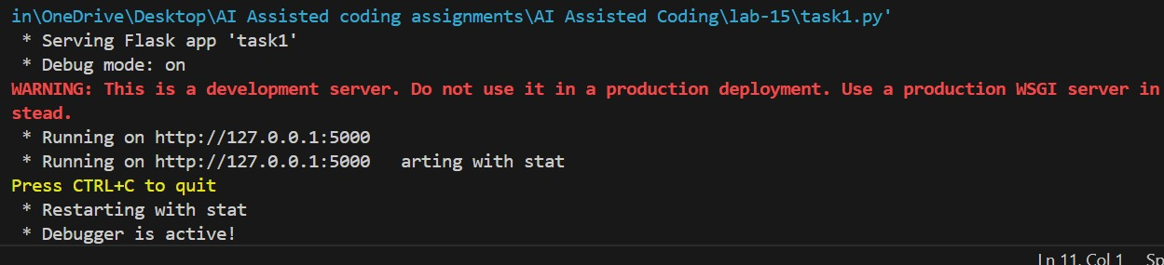
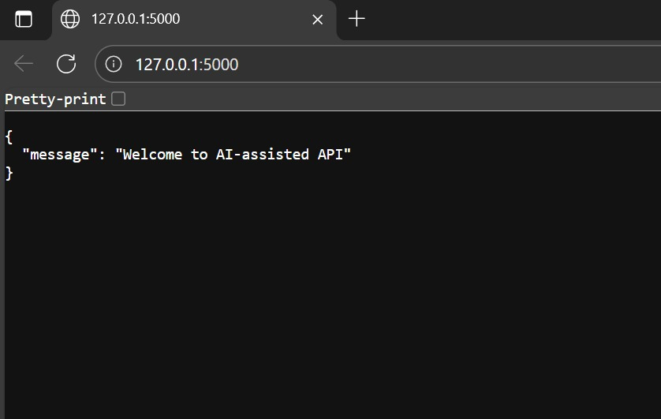
OBSERVATION:
In this code, I observed that Flask is used to create a simple web server with one endpoint. The / route returns a JSON message “Welcome to AI-assisted API” using the jsonify() function. The server runs in debug mode, and when accessed through http://127.0.0.1:5000/, it displays the message correctly in the browser or Postman.
TASK 2:
PROMPT:
Create a simple Flask CRUD API with Read (GET) and Create (POST) operations using an in-memory list.
CODE:
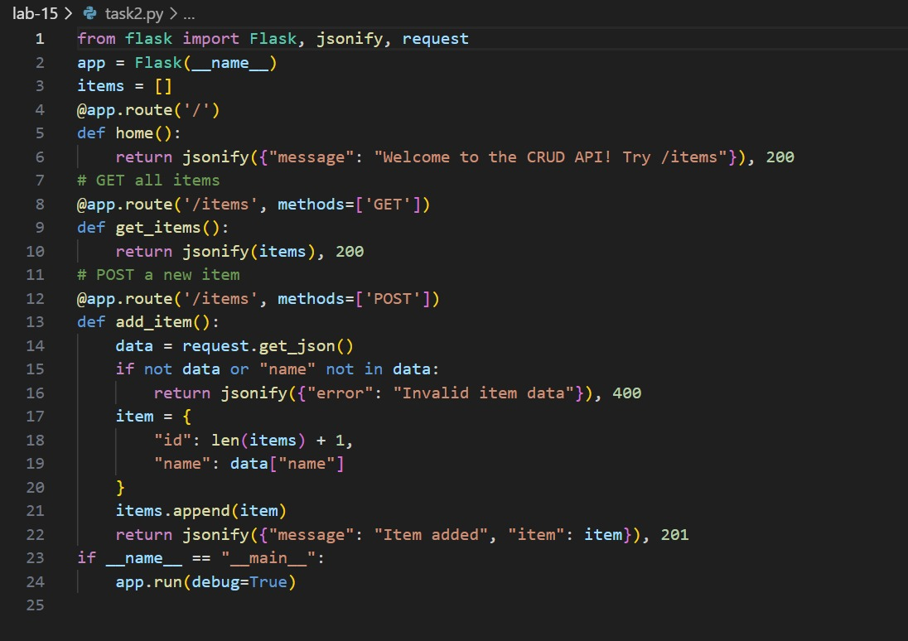
OUTPUT:
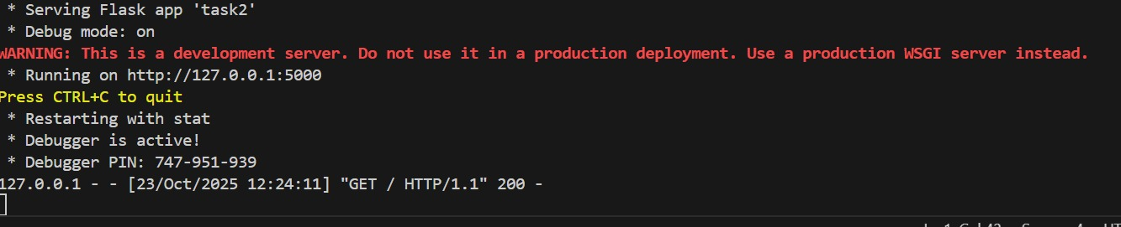
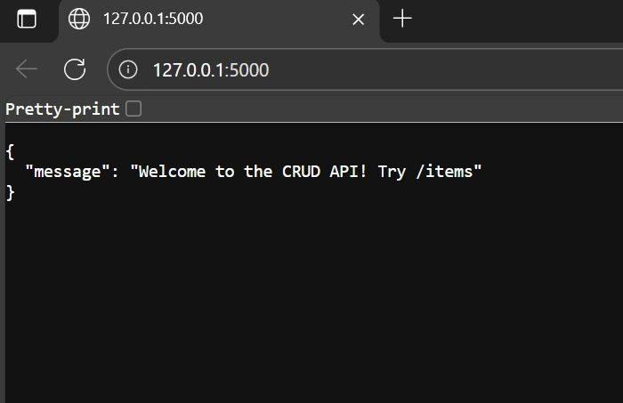
OBSERVATION:
In this code, I observed that Flask is used to create two API endpoints for reading and adding items. The /items route with the GET method returns all items stored in the in-memory list, while the POST method adds a new item received as JSON data. The added item is appended to the list and a success message is returned. Since the data is stored in memory, it will reset when the server restarts. This provides a simple demonstration of basic CRUD operations.
TASK 3:
PROMPT:
Create a PUT endpoint in Flask to update an existing item by its index.
CODE:
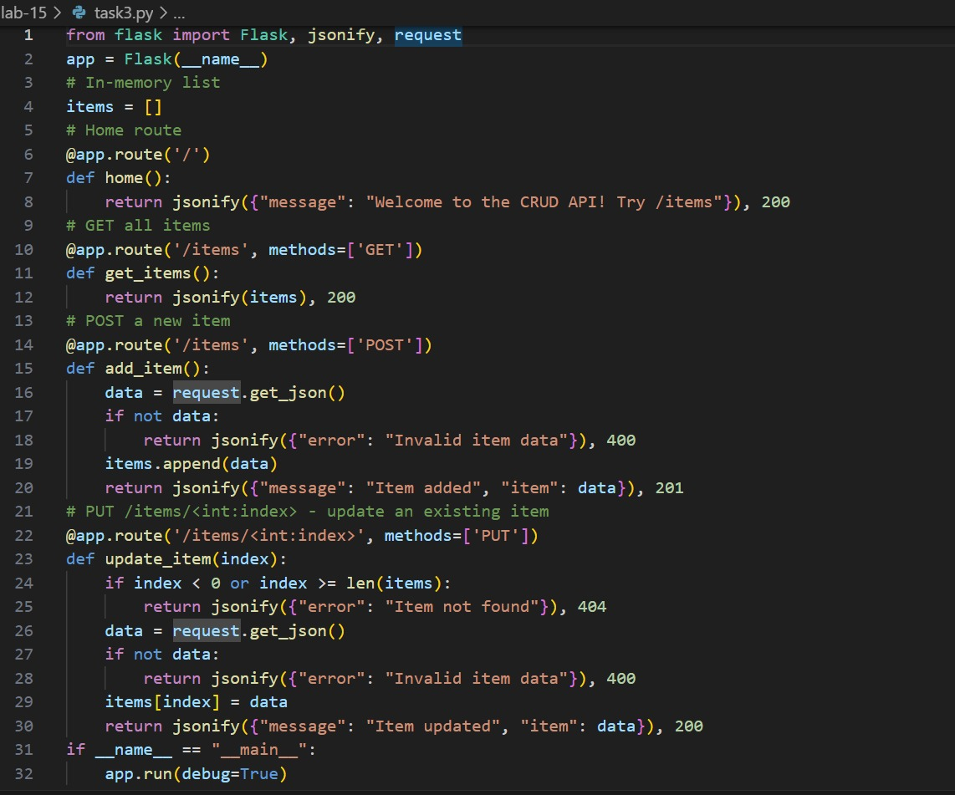
OUTPUT:
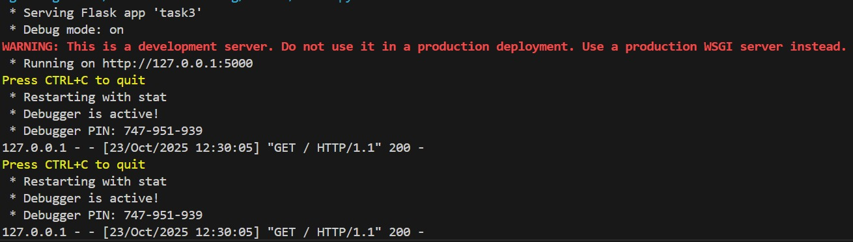
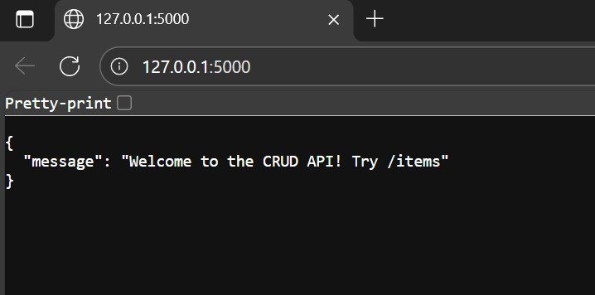
OBSERVATION:
This Flask code defines a PUT endpoint allows updating an existing item in the list based on its index. It first checks if the given index is valid to avoid errors when accessing non-existent items. The new data for the update is received as a JSON payload from the client request and replaces the old item in the list. Finally, the API returns a JSON response containing a success message along with the updated item details, confirming that the update was successful.

